**Comsats University Islamabad**

**Department of Computer Science**

**Assignment no 1**

**Subject: Web Technologies**

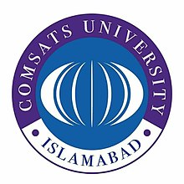

**Submitted to:**

Sir Muhammad Farooq Azam

**Submitted by:**

Bareera Iqbal SP19-BSE-023-6A

Ameer Hamza Abbasi SP19-BSE-016-6A

# **Homepage:**

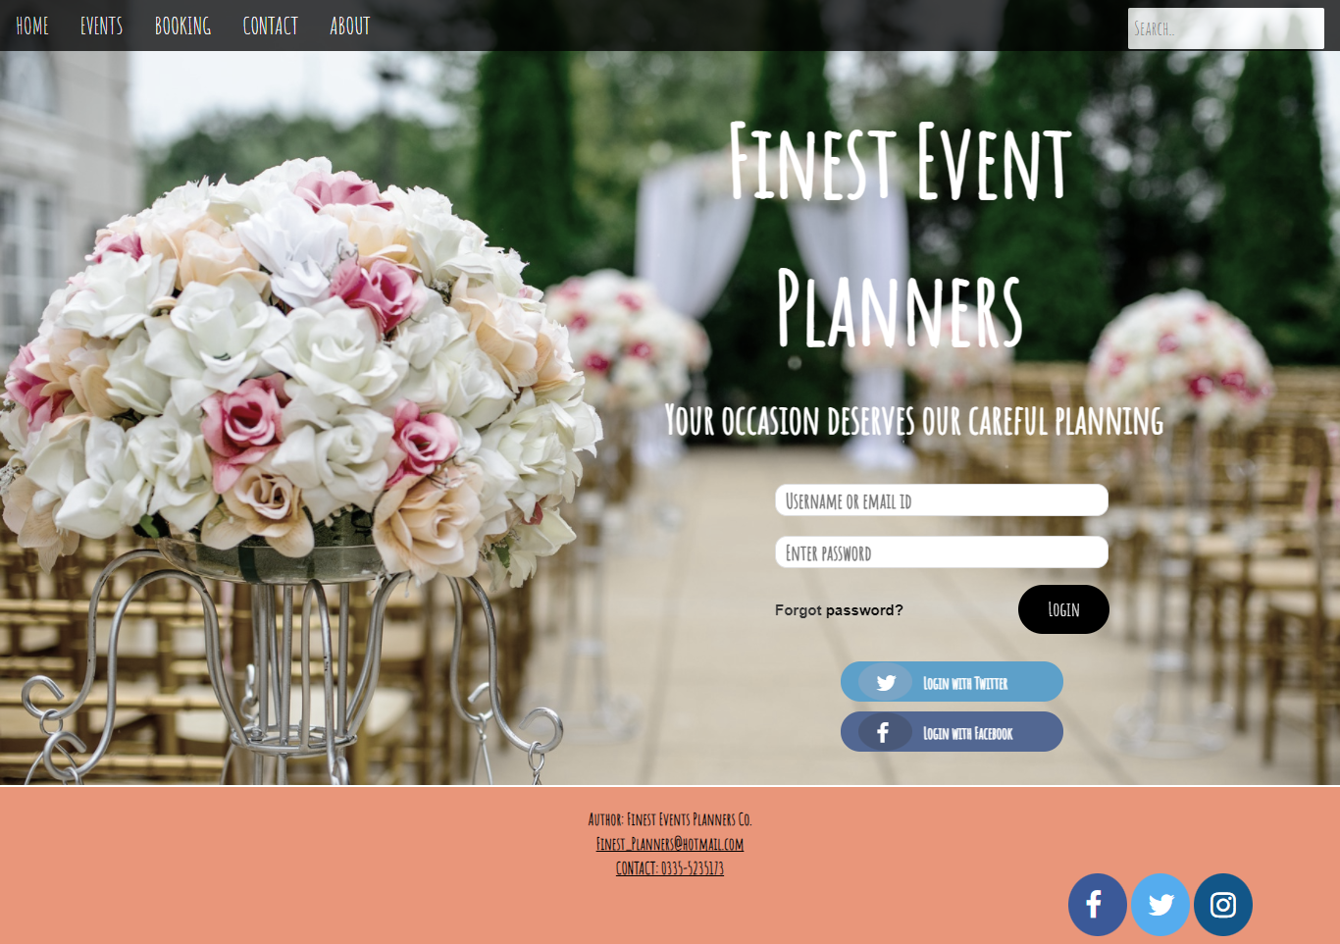



# **Event gallery:**

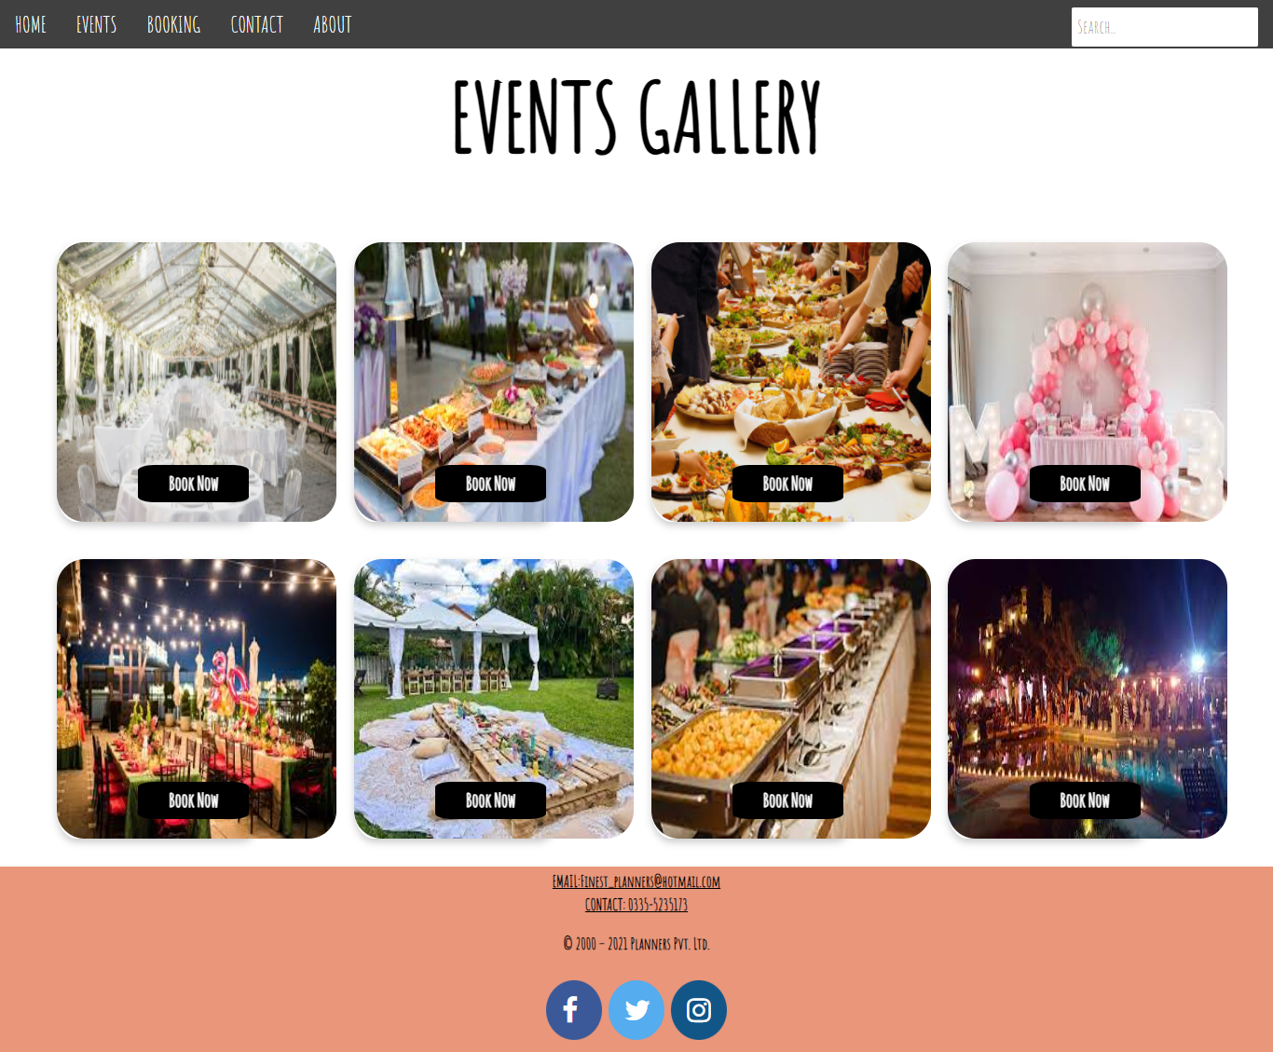



# **Payment- form:**

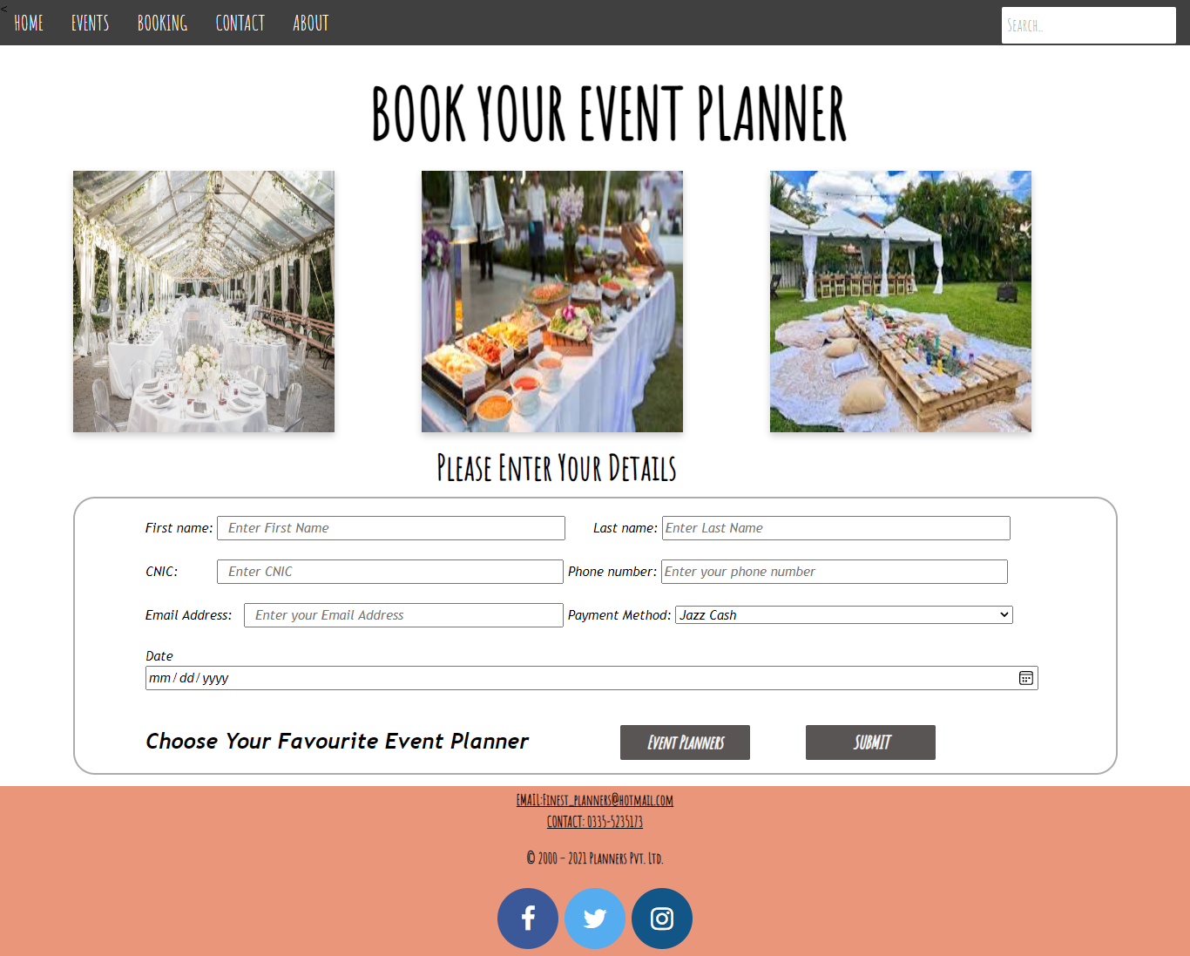



# **About Us Page:**

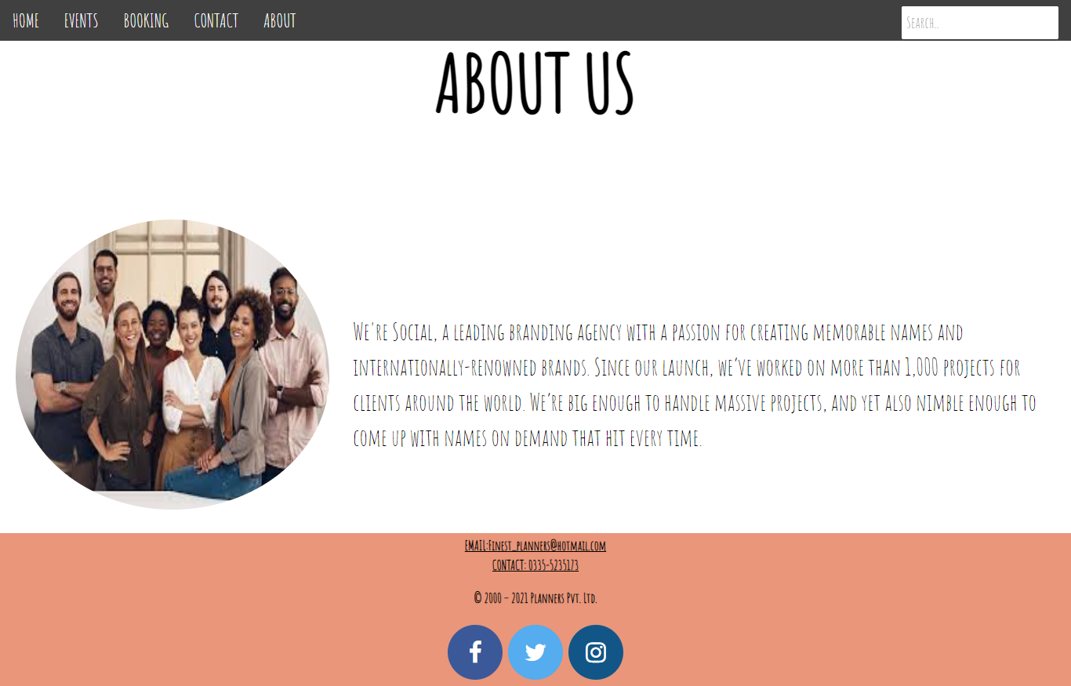



# **Event Details:**

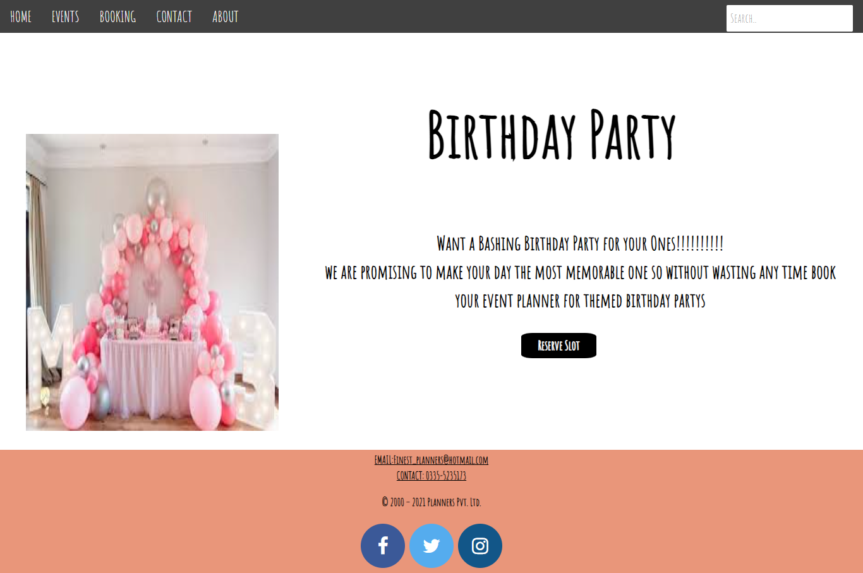



# **Event Planner List:**





